1. **Introduction -**

* **Problem Definition :**

**Project** –*“Vivir - Make your stay easy” ,* an android application for solving the daily life “House Rental and Tenancy” problem.

**Major User** – Tenant(renter) and Owner

**Abstract** – It would be an android application for booking of apartment/flat /room and making easy stay for an user (Tenant/Renter).

*“Tenant”* can search and book the flat. After booking he can do all transaction during the whole stay at that flat through this application. He can complain and communicate with the owner by this application.He will get notification prior to due date of payment. He has to clear all dues before leaving the flat.

*“Owner”* can upload and update flat/room details that he want to lend. He can approve all request of booking and will respond to complaints through this application. Payment details uploaded by the user can be validated.

Each user has their own dashboard section. This application will provide all principle functionalities needed for room owning/renting and easy stay.

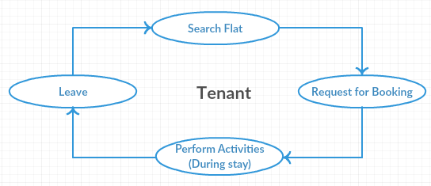

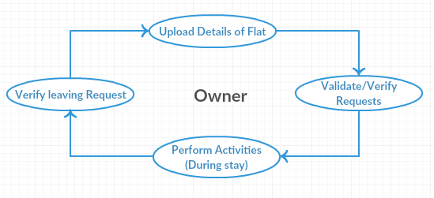

* **Background and Motivations :**

Vivir is a standalone application. It aims to replace the existing manual searching/booking of flats/ rooms and activities associated with that. It just needs an android operating system and Internet connection to perform these activities. Thus, Vivir is a self contained application working with two types of peers - Tenant and Owner.

**How it is useful ?**

**To Tenant** : It will help to a Tenant in following aspects.

* Easy and efficient searching and booking of flats/rooms.
* Easy to stay and
* Removes the conflicts of rent payment and memorization of due date.
* Makes the communication with owner easier.

**To Owner :** Owner will get benefits in following aspects.

* Application will provide an easy way to let their property.
* Approaching to the Customer/Tenant would be easier and efficient.
* Easy to perform all activities needed in room rental.
* Complaint handling and communication with Tenant would be easier.
* Timely payment of rents and no need to memorize/note anything, application will automatically give notifications to both peers.

**To Social aspects :**

* Cost and time efficient, needs only an internet connection and Android phone.
* Will help in maintaining the good relationship between Tenant and Owner.
* Transparency of rent and price.

**2. Literature Survey**

This section will give a brief description of the literature review/survey needed for the early phase of this project. It will discuss the information from the website, and research that has been done.

1. **Manual booking and Tenancy :** In most of the cities and places manual Flat/room searching and booking are working. User/Customer physically go to the place and search for their requirements. After booking the room all associated activities are done manually during the whole stay.
2. **Booking Agencies and commission agents :** Now-a-days several booking agencies are active for providing the details of available flats/rooms in the city. They charge with both parties ( i.e Tenant and Owner) for these information.
3. **Online Websites -** Several websiteare also active also working for room rental and tenancy facilities. Few of them are following

https://www.sulekha.com/ , https://www.nestaway.com/ , https://www.nestpick.com ,

https://www.eurooms.com/

Working with Android application makes the Booking and Tenancy more easier. It just needs and android phone and internet connection and In today’s world most of the users have that.

**3. Solution and Overall Description -**

**Major Functionalities :**

The project will be devised to accomplish the following functionalities. The major user

classes and their associated functionalities are -

**Tenant :**

* Registration and Login
* Searching
* Booking
* Payment Details upload
* Complain
* Notifications
* Communication(Messaging)
* Leave Flat

**Use Case diagram : Tenant**

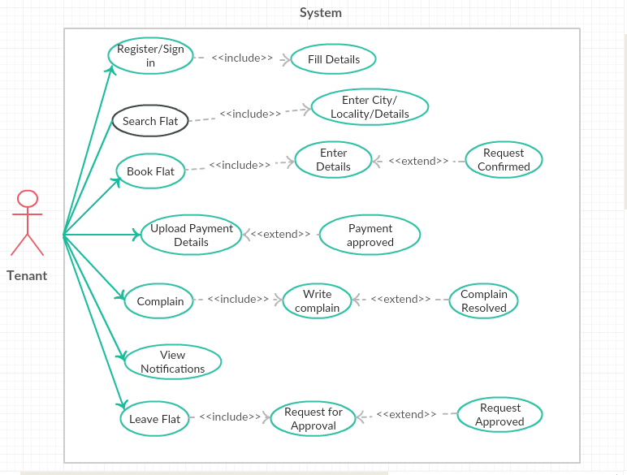

**Owner :**

* Registration/Login
* Upload Flat/Room details
* Approve Booking Request
* Approve Payment Details
* Resolve complaints
* View Notifications
* Verify Requests(leaving..)

**Use Case Diagram : Owner**

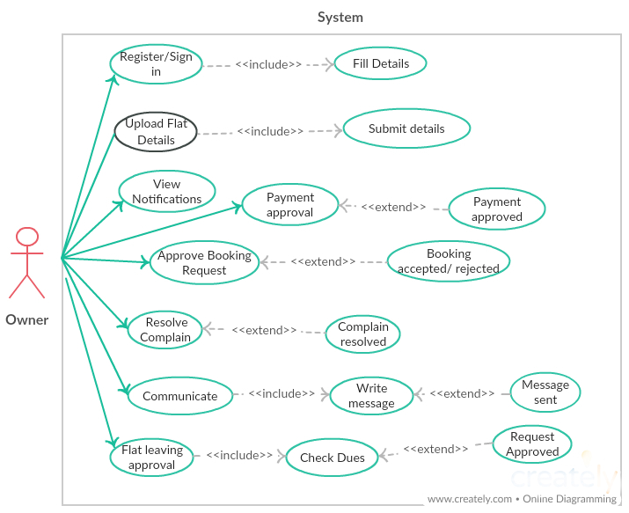

**Minor Functionalities :**

Apart from this there would be several Minor Functionalities. These are the supporting functionalities for maintaining the accurate system flow.

* User Profile setting
* Deleting and updating records
* Change password
* Details managing

**4 - Rough implementation plan :**

Project will be devised to provide best and efficient services. This will include the following aspects and standards.

1. *Android Material design* would be used for designing and creating the user interface. It will provide an interactive and easy interface.
2. *Specific Algorithm* and *Data Structure* would be used to provide best result and with good response time.
3. *Relational Database Concepts* would be used to model and design the database.
4. *Java Coding Convention* will be followed for writing the application code.
5. *MySQL* will be used as global database and *Sqlite* as a local database.

## **5 - Operating and Development Environment**

* **Client Side Requirement**

Operating System : Android OS (android 4.0 and above)

Connectivity: Good Internet connection

* **Server Side Requirements**

Operating System : Linux/Windows/Mac

Development Platform: Android Studio and JVM

Database : MySQL and SQLite

Languages : Java and XML

## **6 - References**

Following are the references that will be used in whole project development

* Android Studio: http://developer.android.com/studio/index.html
* Udacity : https://in.udacity.com/
* Java - The Complete Reference by Herbert Schildt
* XML - www.tutorialspoint.com
* https://en.wikipedia.org/wiki/Android_Studio
* Java Code Conventions - http://www.oracle.com/technetwork/ java/codeconventions- 150003.pdf